Question 1 # 这个部分主要的作用就是理解教材中的一些基本概率
Explain the following terms: [5 marks each]
- Missing Completely At Random (MCAR) # 数据完全随机缺失，所以不会影响结果。
A variable is missing completely at random if the probability of missingness is the same for all units, for example, if each survey respondent decides whether to answer the “earnings” question by rolling a die and refusing to answer if a “6” shows up. If data are missing completely at random, then throwing out cases with missing data does not bias your inferences. 如果数据完全随机缺失，则丢弃缺失数据的案例不会使您的推论产生偏差。

- Missing At Random (MAR) # 这意味着，如果已观测到的数据和其他已知变量足够详尽地描述了缺失数据的缺失机制，那么可以使用已观测到的数据进行缺失数据的推断和分析，而不会导致偏差。
A general assumption for missing at random is that the probability of missingness in a variable for a case depends only on the information provided by other variables. For instance, if sex, race, education, and age are recorded for all the people in the survey, then “earnings” is missing at random if the probability of nonresponse to this question depends only on these other recorded variables. It would therefore be reasonable to model this type of missingness using a logistic regression, where the outcome variable equals 1 for observed cases and 0 for missing. 对另一个变量的每个类别完全随机， 而且变量缺失的概率仅取决于可用信息，因此，缺失数据和其他变量之间的关联是通过已有的数据进行建模和处理的，不会对缺失数据的分布引入特定的、非随机的偏差。

- Missing Not At Random (MNAR) # 是指在缺失数据中存在一些模式或机制，导致缺失的数据不仅与已观测到的数据和其他已知变量有关，还与未观测到的或未知的因素有关。
A missing value that is neither MAR nor MNAR is missing not at random. In particular, this type of missing is because of the value of the missing values itself, or because of a hidden variable. 是指数据缺失的一种模式，其中缺失数据的缺失与未观察到的变量之间存在关联，无法通过已有的数据进行建模和处理，可能引入系统性偏差。

- Cluster Analysis
Cluster Analysis is a type of unsupervised Analysis which is used to classify the cases based on their similarity using their features. As the result, the objects in the same group (called a cluster) are more similar to each other than to those in other clusters. 聚类分析是一种无监督分析，用于根据案例的相似性使用它们的特征对案例进行分类。结果，同一组（称为集群）中的对象比其他集群中的对象彼此更相似。常用的聚类算法包括层次聚类（Hierarchical Clustering）、K均值聚类（K-means Clustering）

- Dissimilarity
In clustering Analysis, as explained above, similar cases are clustered in same group. Similarity of cases is measures based on the distance between each two cases which is the measure of dissimilarity. 在聚类分析中，如上所述，相似的案例被聚类在同一组中。案例的相似性是基于每两个案例之间的距离的度量，这是相异性的度量。

- Rejection sampling
Rejection sampling is a method of generating samples from distribution f using another distribution g, which is used to define the envelop function h. The samples then are generated in 2 dimensions (i.e. (x,u)) from g and a uniform distribution between (0, y) where y is h(x). The samples with u > f(x) are rejected and the remaining sample would have the f distribution. 拒绝采样方法的基本思想是通过从一个辅助分布（proposal distribution）中生成样本，并根据一定的准则接受或拒绝这些样本，从而获得符合目标分布的样本。通常，目标分布是我们希望从中采样的分布，而辅助分布是一个比较简单和易于采样的分布。

- Ensemble # 这个概念就是使用几个决策树，组成一个更复杂的模型
Ensemble is a method that combines several decision trees to produce better predictive performance than utilizing a single decision tree. The main principle behind the ensemble model is that a group of weak learners come together to form a strong learner.
- Factor Analysis
Factor analysis is a statistical method used to describe variability among observed, correlated variables in terms of a potentially lower number of unobserved variables called factors. Factor Analysis is a method of Data Reduction. 因子分析（Factor Analysis）是一种多变量统计分析方法，用于探索和描述多个变量之间的内在结构和关系。它是一种数据降维技术，可以将多个相关变量降维为较少的几个潜在因子，从而减少数据的复杂性并提取变量间的共性信息。
- Varimax Rotation
Varimax rotation is used to simplify the expression of a particular sub-space in terms of just a few major items each. The sub-space found with principal component analysis or factor analysis is expressed as a dense basis with many non-zero weights which makes it hard to interpret. Varimax is so called because it maximizes the sum of the variances of the squared loadings. Varimax 旋转用于简化特定子空间的表达，每个子空间仅包含几个主要项目。目标是通过最大化因子载荷的方差，将因子载荷矩阵中的载荷值在因子方向上集中于一个因子，从而使得因子载荷矩阵更加稀疏和解释性更强。

- Multidimensional Scaling
Multidimensional Scaling is a means of visualizing the level of similarity of individual cases of a dataset. MDS is used to translate "information about the pairwise 'distances' among a set of n objects or individuals" into a configuration of n points mapped into an abstract Cartesian space. 多维缩放（Multidimensional Scaling, MDS）是一种多变量统计方法，用于在低维空间中对高维数据进行可视化和降维。它旨在将原始数据中的多个变量映射到一个较低维度的空间，以便更好地理解数据之间的相似性、距离和关系。

Question 2
Clustering was used to analyse the following dataset:
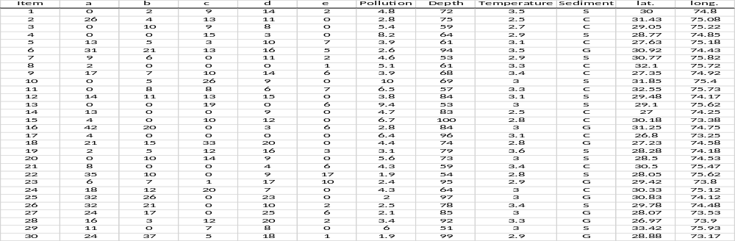
(a) Interpret the following graph as output. [5 marks]
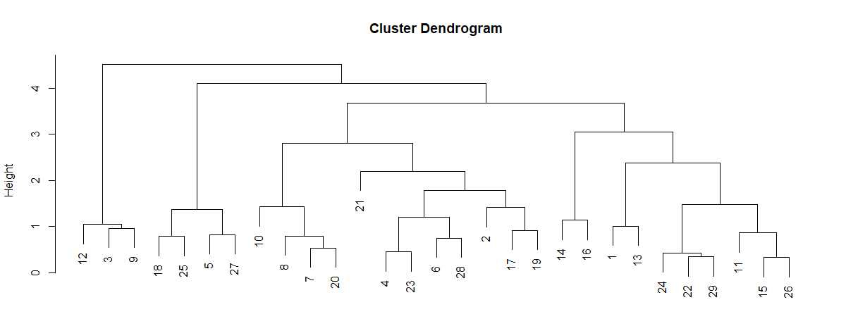
The Dendrogram above shows the similarity between the cases in different levels, based on their distances. For example, cases 4 and 23 seem to be very similar based on the difference between their features. This graph allows us to understand the clusters that each case belongs to, based on similarity between cases. 上面的树状图显示了不同级别案例之间的相似性，基于它们的距离。例如，案例 4 和案例 23 从它们的特征差异来看似乎非常相似。该图使我们能够根据案例之间的相似性了解每个案例所属的集群。

(b) List the items for each cluster, if number of clusters is 4. [5 marks]
12,3,9 ｜ 18, 25, 5, 27 ｜ 10, 8, 7, 20, 21, 4, 23, 6, 28, 2, 17, 19 ｜ 14, 16, 1, 13, 24, 22, 29, 11, 15, 26

(c) What does the following graph show (xst and yst are standardised figures for x and y)?
[5 marks]
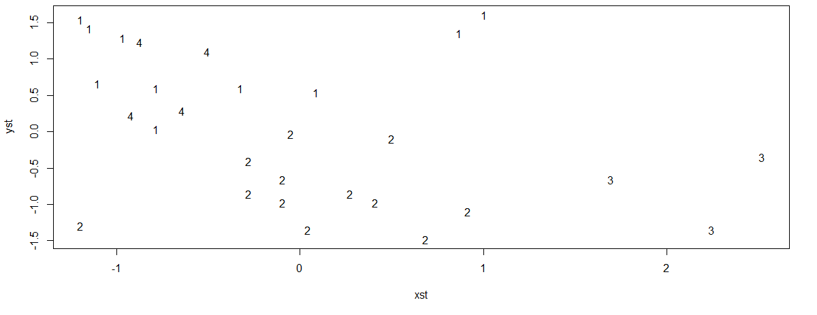
The graph shows the scatter plot for two standardised features and the cluster of the cases. This can be used to visualise how a certain level of each feature may affect the cluster of each case. For instance, it shows that for negative yst, the cases are clustered in clusters 2 or 3. 该图显示了两个标准化特征和个案集群的散点图。这可用于可视化每个特征的特定级别如何影响每个案例的集群。例如，它显示对于负 yst，个案聚集在聚类 2 或 3 中。

(d) Explain the difference between Decision Tree and Cluster Analysis. [5 marks]
The main difference is that Decision Tree is a supervised analysis white Clustering is an unsupervised one. In other words, while in essence both are used for classification, the groups or classes in Decision Tree are predefined using the model dependent variables, but are unknown and therefore defined by the model in cluster analysis. 主要区别在于决策树是一种监督分析，而聚类是一种无监督分析。换句话说，虽然本质上两者都用于分类，但决策树中的组或类是使用模型因变量预定义的，但在聚类分析中是未知的，因此由模型定义。

Question 3 # 这个是对具体公式的解释，这个已经相当困难了。
The following R syntax is used to make decision whether to grant loan to each applicant based on the values of the variables in their profile.
DT_Model <- rpart(RESPONSE~., data=Data, control=rpart.control(minsplit=60, minbucket=30, maxdepth=4)
(a) Explain the syntax with all details. [5 marks]
A classification tree can be fitted using rpart function. 可以使用 rpart 函数拟合分类树。
RESPONSE~. Indicates that all variables within the dataset “Data” are used to predict the RESPONSE variable. 示数据集“Data”中的所有变量都用于预测 RESPONSE 变量。
rpart.control consists of 3 parts:
minsplit: the minimum number of observations that must exist in a node required for a split to be attempted. 尝试拆分所需的节点中必须存在的最小观察数。
minbucket: the minimum number of observations in any terminal <leaf> node. 任何终端 <leaf> 节点中的最小观察数。
maxdepth: the maximum depth of any node of the final tree, with the root node counted as depth 0. 最终树的任意节点的最大深度，根节点算作深度0。

(b) Interpret the graphical output below. [10 marks]
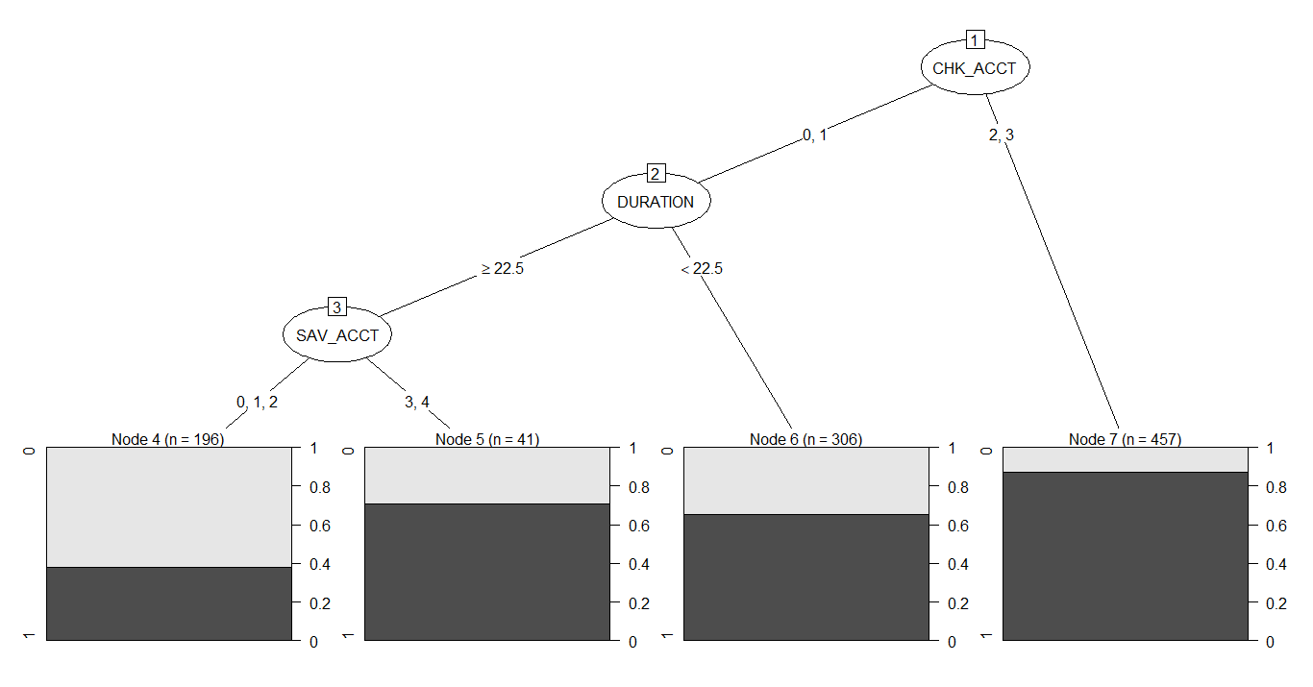For those observations with CHK_ACCT = 2,3 above around 85% have RESPONSE=1. For those with CHK_ACCT = 0,1 the next decision node is DURATION. Where DURATION < 22.5, above 60% of observations shows RESPONSE=1. If DURATION  22.5, the variable SAV_ACCT is the next decision node. Where SAV_ACCT = 3,4 about 70% of observations shows RESPONSE=1. If SAV_ACCT = 0,1,2, about 40%. Of observations have RESPONSE=1. 对于那些 CHK_ACCT = 2,3 的观察结果，大约 85% 以上的结果有 RESPONSE=1。对于 CHK_ACCT = 0,1 的节点，下一个决策节点是 DURATION。当 DURATION < 22.5 时，超过 60% 的观察结果显示 RESPONSE=1。如果 DURATION  22.5，变量 SAV_ACCT 是下一个决策节点。其中 SAV_ACCT = 3,4 大约 70% 的观察结果显示 RESPONSE=1。如果 SAV_ACCT = 0,1,2，大约 40%。的观察结果有 RESPONSE=1。

(c) Choose one of the terminal nodes in the results shown below and explain the output. [5 marks]
node), split, n, loss, yval, (yprob) * denotes terminal node

1) root 1000 300 1 (0.3000000 0.7000000)
2) CHK_ACCT=0,1 543 240 1 (0.4419890 0.5580110)
7) CHK_ACCT=2,3 457 60 1 (0.1312910 0.8687090) *
3) DURATION>=22.5 237 103 0 (0.5654008 0.4345992)
6) DURATION< 22.5 306 106 1 (0.3464052 0.6535948) *
4) SAV_ACCT=0,1,2 196 74 0 (0.6224490 0.3775510) *
5) SAV_ACCT=3,4 41 12 1 (0.2926829 0.7073171) *
For the node (2) where CHK_ACCT=0 or 1, 240 observations out of 543, equivalent to 44%, showed RESPONSE=0 and about 56% showed RESPONSE=1. This node, however, is not a terminal node. In node (7) where CHK_ACCT=2 or 3, 60 observations out of 457, equivalent to 13%, showed RESPONSE=0 and about 87% showed RESPONSE=1. This node, is a terminal node. 对于 CHK_ACCT=0 或 1 的节点 (2)，543 个观测值中有 240 个（相当于 44%）显示 RESPONSE=0，约 56% 显示 RESPONSE=1。然而，该节点不是终端节点。在 CHK_ACCT=2 或 3 的节点 (7) 中，457 个观测值中有 60 个（相当于 13%）显示 RESPONSE=0，约 87% 显示 RESPONSE=1。这个节点，是一个终端节点。

Question 4 # 解释回归树
(a) Explain what a regression tree is? [5 marks]
A decision tree is a flowchart-like structure in which each internal node represents a "test" on an attribute, each branch represents the outcome of the test, and each leaf node represents a class label (decision taken after computing all attributes). The paths from root to leaf represent classification rules. A regression tree is similar to a classification tree, except that the Y variable takes numerical values and a regression model is fitted to each node to give the predicted values of Y. 回归树是决策树的一种特殊形式。｜回归树（Regression Tree）是一种用于建立回归模型的决策树算法。它通过对输入特征的递归二分进行分割，将数据集划分为多个子集，并在每个叶节点处拟合一个回归模型，从而实现对目标变量的预测。｜决策树是一种类似流程图的结构，其中每个内部节点代表对属性的 “测试” ，每个分支代表测试的结果，每个叶节点代表一个类标签（计算所有属性后做出的决定）。从根到叶的路径表示分类规则。回归树类似于分类树，不同之处在于 Y 变量取数值，并且对每个节点拟合回归模型以给出 Y 的预测值。

(b) Explain the advantage of a regression tree over multiple linear regression. [5 marks]
Linear regression is a linear model, which means it performs properly when the link between the response and predictors is linear. However, when the data has a non-linear shape, then a linear model cannot capture the non-linear relationship. Therefore, while linear regression would suffice for many applications, there are many others where it fails to perform adequately. Regression trees, on the other hand, give us a piecewise linear relationship between the predictor and the response that is freed from the constraints of continuities at the joins between the different segments. 当数据具有非线性形状时，线性模型无法捕获非线性关系。因此，虽然线性回归足以满足许多应用，但还有许多其他应用无法充分发挥作用。另一方面，回归树为我们提供了预测变量和响应之间的分段线性关系，该关系不受不同段之间连接处的连续性约束。｜ 回归树在处理非线性关系、具有可解释性、对数据缺失值和离群值鲁棒性强以及非参数性等方面相对于多元线性回归具有优势。

Fuel consumption is analysed using regression tree.
(c) Interpret the graph below. [5 marks]
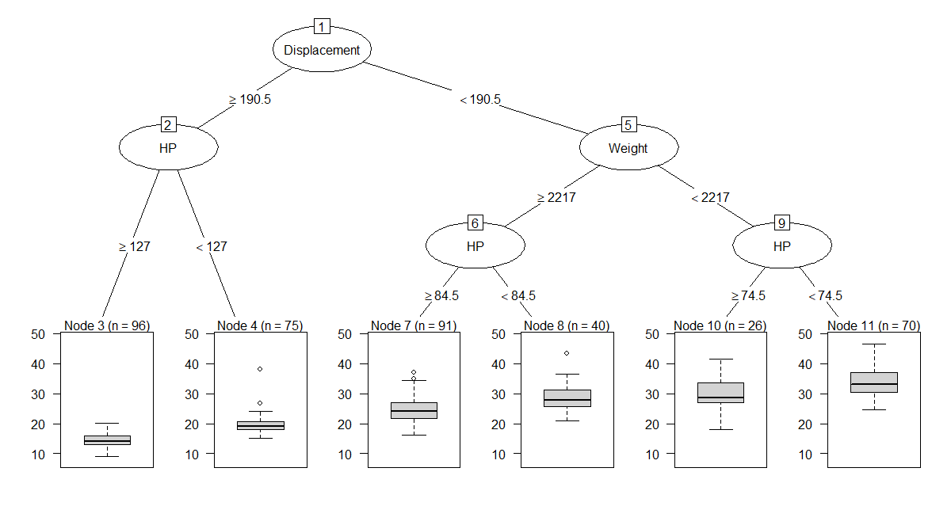
排气量（Displacement）， hp：马力
At node 3 with 96 observation, with displacement  190.5 and HP (horse power)  127, the box plot shows the variation of the fule consumption with median about 15. 在节点 3 96 次观察，排量>190.5 和 HP（马力）> 127 时，箱形图显示燃料消耗量的变化，中位数约为 15。

(d) Explain the following the table and graph. How many number of Splits do you suggest? [10 marks]
CP nsplit rel error xerror xstd
1 0.57654632 0 1.0000000 1.0051577 0.06114786
2 0.10765980 1 0.4234537 0.4442595 0.03876053
3 0.04236603 2 0.3157939 0.3758393 0.03526972
4 0.01710748 3 0.2734279 0.3237557 0.03341855
5 0.01128780 4 0.2563204 0.3121954 0.03305469
6 0.01000000 5 0.2450326 0.3030461 0.03218785
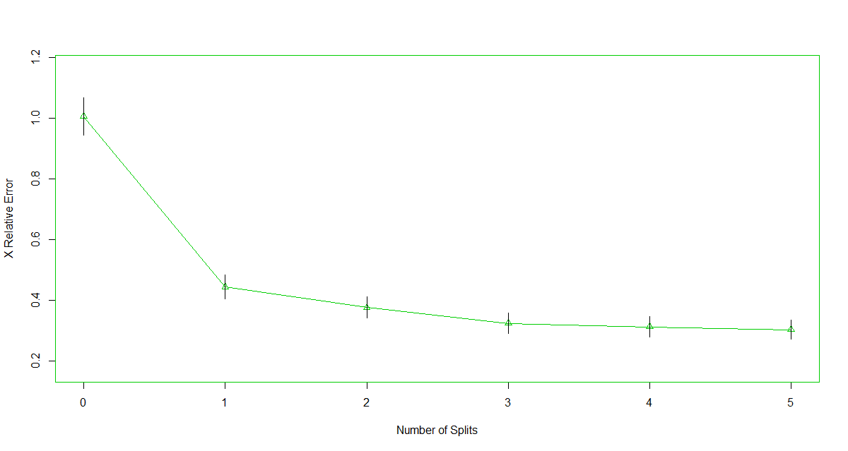
Each row of the table, represents a different number of splits or actually the height of the tree. In general, more number of split the tree mean that it has lower classification error on the training set. ｜The complexity parameter (cp) is used to control the size of the decision tree and to select the optimal tree size. If the cost of adding another variable to the decision tree from the current node is above the value of cp, then tree building does not continue. We could also say that tree construction does not continue unless it would decrease the overall lack of fit by a factor of cp. ｜rel_error is simillar to 1-R2 in linear regression. ｜x-error is the cross-validation error, as rpart has built-in cross validation. We use the 3 columns, rel_error, xerror and xstd together to choose where to prune the tree. A rule of thumb is to choose the lowest level where the rel_error + xstd < xerror ｜xstd is the proportion of original observations that were misclassified by various subsets of the original tree. ｜3 splits seems to be apropper choice as rel-error would not improve afterward with the same rate as before 3 splits. ｜ 表格的每一行代表不同的分割数或树的实际高度。一般来说，更多的分裂树意味着它在训练集上的分类错误率更低。｜ 复杂性参数 (cp) 用于控制决策树的大小并选择最佳树大小。如果从当前节点向决策树添加另一个变量的成本高于 cp 的值，则不会继续构建树。我们也可以说树的构建不会继续，除非它可以将整体失配降低 cp 倍。｜ rel_error 类似于线性回归中的 1-R2。｜ x-error 是交叉验证错误，因为 rpart 具有内置的交叉验证。我们一起使用 3 列 rel_error、xerror 和 xstd 来选择修剪树的位置。经验法则是选择 rel_error + xstd < xerror 的最低级别。｜ xstd 是被原始树的各个子集错误分类的原始观测值的比例。｜ 3 次拆分似乎是一个合适的选择，因为相对错误之后不会以与 3 次拆分之前相同的速率改善。
Q5. # 解释累积概率
The cumulative probability function of a random variable X is a function of X and therefore can be assumed as a random variable. It was shown during a lectures that this random variable has a continuous uniform distribution. 随机变量 X 的累积概率函数是 X 的函数，因此可以假设为随机变量。在讲座中表明，该随机变量具有连续均匀分布。
- Explain how the result of this theorem could be used to generate sample from a particular distribution. [5 marks]
The result of the theorem suggests that the inverse function of the cumulative probability function of a particular distribution can be used to convert the uniform samples of U(0,1) to the samples of the particular distribution. 该定理的结果表明，可以使用特定分布的累积概率函数的反函数将 U(0,1) 的均匀样本转换为特定分布的样本。
- Using an example, explain what would be the challenge in using this theorem? [5 marks]
For some distributions such as Gamma, the cumulative probability function and therefore the inverse cannot be presented as a closed form mathematical function. 对于某些分布，例如 Gamma，累积概率函数及其逆函数不能表示为封闭形式的数学函数。
(a) Explain what a decision tree is? [8 marks]
决策树是一种基于图形结构的数据分析和决策支持技术，用于解决分类（分类树）和回归（回归树）问题。它通过对数据集的特征进行递归分割，生成一个树状结构，其中每个节点表示一个特征的判断条件，每个分支代表一个特征值的不同取值，叶节点表示最终的分类或回归结果。
(c) Explain the differences between regression tree and multiple linear regression. [8 marks]
决策树回归（Regression Tree）和多元线性回归（Multiple Linear Regression）是两种不同的预测建模方法，它们在建模方式、模型形式和应用场景等方面存在一些显著的区别。
- 建模方式：决策树回归是一种非参数方法，通过对数据进行递归划分来构建一棵树形结构，其中每个叶节点代表一个预测值。而多元线性回归是一种参数方法，通过拟合一个线性模型来建立输入特征和输出变量之间的线性关系。
- 模型形式：决策树回归生成的模型是一棵树形结构，其中每个叶节点都对应一个预测值，而输入特征的取值通过树的分支路径来决定。而多元线性回归生成的模型是一个线性方程，其中输入特征通过权重系数与输出变量进行线性组合，再加上一个常数截距。
- 处理非线性关系：决策树回归可以自动捕捉输入特征与输出变量之间的非线性关系，因为树的分支路径可以包含非线性的划分规则。而多元线性回归只能建模线性关系，无法直接捕捉非线性关系，需要通过特征工程或引入非线性特征进行处理。
- 预测解释性：决策树回归生成的模型具有较好的解释性，可以直观地展示输入特征的重要性和决策路径。而多元线性回归生成的模型较为简单，权重系数可以解释输入特征对输出变量的影响，但没有明显的决策路径。
- 应用场景：决策树回归适用于处理离散型和连续型特征的预测问题，特别适合处理具有非线性关系的数据。而多元线性回归适用于处理具有线性关系的数据，输入特征和输出变量之间的关系可以通过线性方程进行建模。
因此，决策树回归和多元线性回归在建模方式、模型形式、处理非线性关系、预测解释性和应用场景等方面存在一些显著的区别。选择合适的方法取决于具体的数据特征和预测需求。

(a) ensemble [6 marks]
集成学习（Ensemble Learning）是一种将多个弱学习器（模型）组合成一个强学习器的机器学习方法。通过将多个模型的预测结果进行组合，可以提高模型的泛化性能，从而改善模型的预测准确性、稳定性和鲁棒性。
集成学习通过将多个模型的预测结果进行加权平均、投票、堆叠等方式进行组合，从而产生一个更为综合和稳健的预测结果。集成学习可以应用于各种机器学习任务，包括分类、回归、聚类等，且在很多实际问题中都取得了良好的效果。

(b) Random forest [6 marks]
随机森林（Random Forest）是一种集成学习方法，用于解决分类和回归问题。它是一种基于决策树（Decision Tree）的集成方法，通过在数据集中随机抽取子样本和特征的方式，构建多个决策树，再通过集成它们的预测结果来提高模型的泛化性能。

(c) Bagging [7 marks]
装袋法（Bagging）是一种集成学习方法，用于通过并行训练多个基础模型，再通过投票或平均等方式集成它们的预测结果来提高模型的泛化性能。
装袋法的主要步骤包括：
数据抽样：从原始数据集中随机抽取多个子样本，每个子样本用于训练一个基础模型。这些子样本之间相互独立且有放回地抽取，使得每个子样本可能包含重复的数据。
并行训练：使用不同的子样本训练多个基础模型，通常每个子样本都采用相同的基础模型算法。这些基础模型可以在并行计算的环境中同时训练，从而提高训练效率。
集成预测：将多个基础模型的预测结果进行集成，通常通过投票、平均等方式。对于分类问题，装袋法可以通过统计各个基础模型的预测结果的类别出现频率来进行投票；对于回归问题，可以通过取多个基础模型的预测结果的平均值来进行集成。

QUESTION 1
In a classification tree, the variable that appears as the first split, reduces the GINI index ....... than other variables.
 | a. | less
 | b. | more

QUESTION 2
In the following Dendrogram, for splitting the dataset into 6 clusters, how many cases would be in the cluster with the lowest number of cases?
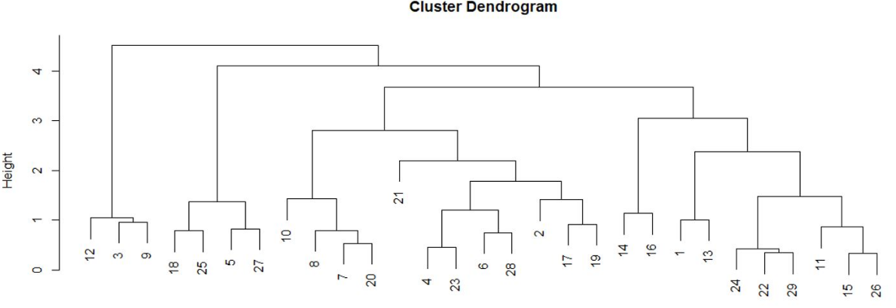
 | a. | 1
 | b. | 2
 | c. | 5
 | d. | 3

QUESTION 3
In the following graph, the output of a clustering analysis, Xst and Yst are standardized X and Y features.
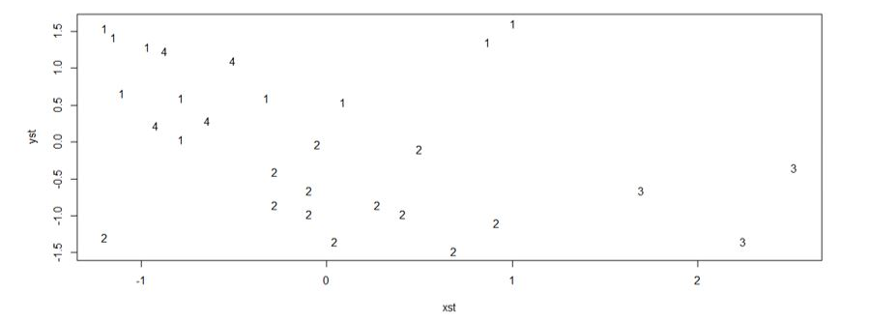
Which of the following rules purely determines one of clusters?
 | a. | Xst>0, Yst<0
 | b. | Xst<0, Yst >0
 | c. | Xst<0, Yst>1
 | d. | Xst>1.50, Yst<1

QUESTION 4
- The inversion method of sampling is based on the theorem that if you apply the transformation Y=F(x) to the samples generated from random variable X with the pdf f(x), the distribution of the y samples is: (F(x) is the cumulative density function of random variable X.)
 | a. | f⁻¹(x)
 | b. | F⁻¹(x)
 | c. | Normal(0,1)
 | d. | Uniform (0,1)

QUESTION 5
In a regression tree with the following output, how many numbers of splits is suggested?
CP nsplit rel error xerror xstd
1 0.67654632 0 1.0000000 1.0051577 0.06114786
2 0.11265980 1 0.4323537 0.4342595 0.04876053
3 0.04236603 2 0.3137939 0.3458393 0.04326972
4 0.01710748 3 0.2634279 0.3337557 0.04141855
5 0.01128780 4 0.2563204 0.3121954 0.03105469
6 0.01000000 5 0.2450326 0.3030461 0.03218785

 | a. | 2
 | b. | 5
 | c. | 3
 | d. | 4

